Counter 4-bit
Code:
library IEEE;
use IEEE.STD_LOGIC_1164.ALL;
use IEEE.STD_LOGIC_UNSIGNED.ALL;

entity Counter_4 is
port(
rst : in STD_LOGIC;
pr : in STD_LOGIC;
clk : in STD_LOGIC;
clk_div : inout STD_LOGIC;
dir : in STD_LOGIC;
Q : out STD_LOGIC_VECTOR (3 downto 0)
);
end Counter_4;

architecture Behavioral of Counter_4 is
signal Qtemp : STD_LOGIC_VECTOR (3 downto 0) := "0000";
signal Counter : STD_LOGIC_VECTOR (26 downto 0) := (others => '0');
begin
process(rst,pr,clk_div,dir)
begin
if rst ='1' then
Qtemp <= (OTHERS =>'0');
elsif pr='1' then
Qtemp <= (OTHERS =>'1');
elsif falling_edge(clk_div) then
if dir = '1' then
if Qtemp < 15 then
Qtemp <= Qtemp + 1;
else
Qtemp <= "0000";
end if;
else
if Qtemp > 0 then
Qtemp <= Qtemp - 1;
else
Qtemp <= "1111";
end if;
end if;
end if;
end process;
Q <= Qtemp;

process(clk)
begin
if clk'event and clk = '1' then
counter <= counter + 1;
end if;
end process;
clk_div <= counter(0);
end Behavioral;

TestBench:
library IEEE;
use IEEE.STD_LOGIC_1164.ALL;
use IEEE.STD_LOGIC_UNSIGNED.ALL;

entity Counter_4_TB is
end Counter_4_TB;

architecture Behavioral of Counter_4_TB is
component Counter_4 is
port(
rst : in STD_LOGIC;
pr : in STD_LOGIC;
clk : in STD_LOGIC;
clk_div : inout std_logic;
dir : in STD_LOGIC;
Q : out STD_LOGIC_VECTOR (3 downto 0)
);
end component;

signal rst : std_logic := '0';
signal pr : std_logic := '0';
signal clk : std_logic := '0';
signal clk_div : std_logic := '0';
signal dir : std_logic := '0';
signal Q : std_logic_vector(3 downto 0);

begin
uut: Counter_4 port map(rst, pr, clk, clk_div, dir, Q);

clk_process : process
begin
clk <= '0';
wait for 10 ns;
clk <= '1';
wait for 10 ns;
end process;

stim_proc : process
begin
rst <= '1';
wait for 20 ns;
rst <= '0';

--Up Counter
dir <= '1';
wait for 500 ns;

pr <= '1';
wait for 20 ns;
pr <= '0';

--Down Counter
dir <= '0';
wait for 300 ns;

wait;
end process;
end Behavioral;

Constraints:
set_property PACKAGE_PIN L1 [get_ports {Q[3]}]
set_property PACKAGE_PIN P1 [get_ports {Q[2]}]
set_property PACKAGE_PIN N3 [get_ports {Q[1]}]
set_property PACKAGE_PIN P3 [get_ports {Q[0]}]
set_property IOSTANDARD LVCMOS33 [get_ports {Q[3]}]
set_property IOSTANDARD LVCMOS33 [get_ports {Q[2]}]
set_property IOSTANDARD LVCMOS33 [get_ports {Q[1]}]
set_property IOSTANDARD LVCMOS33 [get_ports {Q[0]}]
set_property PACKAGE_PIN W5 [get_ports clk]
set_property PACKAGE_PIN U16 [get_ports clk_div]
set_property PACKAGE_PIN R2 [get_ports dir]
set_property PACKAGE_PIN T1 [get_ports pr]
set_property PACKAGE_PIN U1 [get_ports rst]
set_property IOSTANDARD LVCMOS33 [get_ports clk]
set_property IOSTANDARD LVCMOS33 [get_ports clk_div]
set_property IOSTANDARD LVCMOS33 [get_ports dir]
set_property IOSTANDARD LVCMOS33 [get_ports pr]
set_property IOSTANDARD LVCMOS33 [get_ports rst]

set_property CLOCK_DEDICATED_ROUTE FALSE [get_nets pr_IBUF]

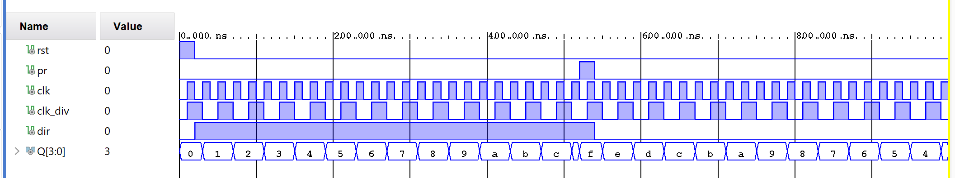

MOD 25 Counter
Code:
library IEEE;
use IEEE.STD_LOGIC_1164.ALL;
use IEEE.STD_LOGIC_UNSIGNED.ALL;
entity mod25 is
Port (
rst : in STD_LOGIC;
pr : in STD_LOGIC;
clk : in STD_LOGIC;
clk_div : inout STD_LOGIC;
dir : in STD_LOGIC;
Q : out STD_LOGIC_VECTOR(4 downto 0)
);
end mod25;
architecture mod25_arch of mod25 is
signal Qtemp : STD_LOGIC_VECTOR(4 downto 0) := "00000";
signal Counter : STD_LOGIC_VECTOR (27 downto 0) := (others => '0');
begin
process(rst, pr, clk, dir)
begin
if rst = '1' then
Qtemp <= (others => '0');

elsif pr = '1' then
Qtemp <= (others => '1');

elsif falling_edge(clk) then
if dir = '1' then --UP counting
if Qtemp < 24 then
Qtemp <= Qtemp + 1;
else
Qtemp <= "00000";
end if;
else --DOWN counting
if Qtemp > 7 then
Qtemp <= Qtemp -1;
else
Qtemp <= "11111";
end if;
end if;
end if;
end process;
Q <= Qtemp;

process(clk)
begin
if clk'event and clk = '1' then
counter <= counter + 1;
end if;
end process;
clk_div <= counter(0);
end mod25_arch;

Test Bench:
library IEEE;
use IEEE.STD_LOGIC_1164.ALL;
entity mod25_tb is
end mod25_tb;
architecture Behavioral of mod25_tb is
--Component Declaration for the Unit Under Test (UUT)
component mod25
Port (
rst : in STD_LOGIC;
pr : in STD_LOGIC;
clk : in STD_LOGIC;
clk_div : inout STD_LOGIC;
dir : in STD_LOGIC;
Q : out STD_LOGIC_VECTOR(4 downto 0)
);
end component;
--Signals to connect to the UUT
signal rst : STD_LOGIC := '0';
signal pr : STD_LOGIC := '0';
signal clk : STD_LOGIC := '0';
signal clk_div : STD_LOGIC := '0';
signal dir : STD_LOGIC := '1'; --default: up count
signal Q : STD_LOGIC_VECTOR(4 downto 0);
begin
--Instantiate the Unit Under Test (UUT)
uut: mod25
port map (
rst => rst,
pr => pr,
clk => clk,
clk_div => clk_div,
dir => dir,
Q => Q
);
--Clock generation: 10 ns period (falling edge sensitive)
clk_process : process
begin
while true loop
clk <= '1';
wait for 5 ns;
clk <= '0';
wait for 5 ns;
end loop;
end process;
--Stimulus process
stim_proc: process
begin
--Initial reset
rst <= '1';
wait for 20 ns;
rst <= '0';
wait for 20 ns;
--Up count for a few cycles
dir <= '1'; --count up
wait for 300 ns;
--Now preset
pr <= '1';
wait for 20 ns;
pr <= '0';
wait for 20 ns;
--Down count
dir <= '0';
wait for 300 ns;
--Apply reset again
rst <= '1';
wait for 20 ns;
rst <= '0';
--End simulation
wait;
end process;
end Behavioral;

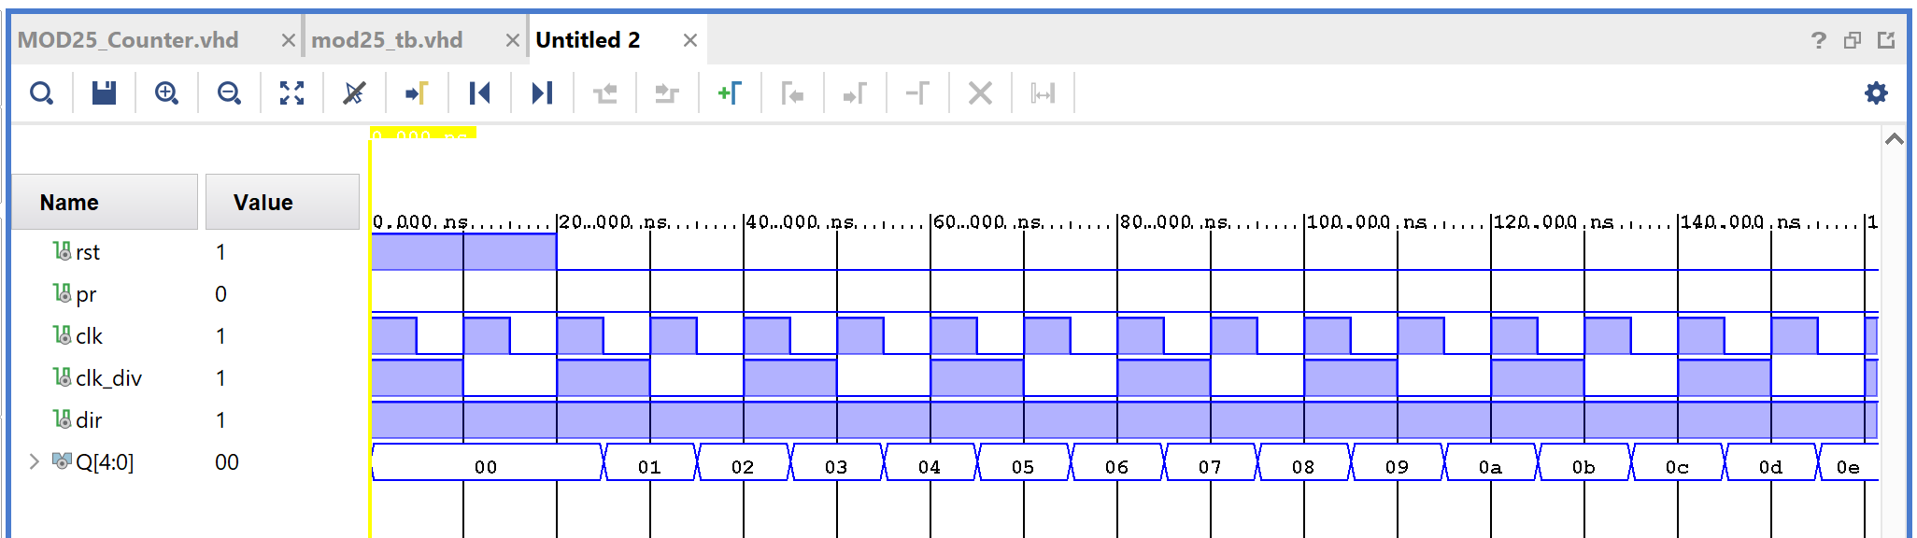

Universal Shit Register
Code:
library ieee;
use ieee.std_logic_1164.all;
use ieee.std_logic_unsigned.all;

entity USR_Code is
port (
clk : in std_logic;
clk_div : inout std_logic;
rst : in std_logic;
load : in std_logic;
mode : in std_logic_vector (1 downto 0);
si : in std_logic;
pi : in std_logic_vector (3 downto 0);
so : out std_logic;
po : out std_logic (3 downto 0)
);
end USR_Code;

architecture beh of USR_Code is
signal shift_reg : std_logic_vector(3 downto 0);
signal counter : std_logic_vector (26 downto 0) := (others => ‘0’);
begin
process(clk)
begin
if clk’event and clk = ‘1’ then
if rst = ‘1’ then
counter <= (others => ‘0’);
else
counter <= counter + 1;
end if;
end if;
end process;
clk_div <= counter(0);

process(clk_div, rst, load)
begin
if rst = ‘1’ then
shift_reg <= (others => ‘0’);
elsif
clk_div’event and clk_div = ‘1’ then
case mode is
when “00” =>
shift_reg(3 downto 1) <= shift_reg(2 downto 0);
shift_reg(0) <= si;
so <= shift_reg(3);
when “01” =>
shift_reg(3 downto 1) <= shift_reg(2 downto 0);
shift_reg(0) <= si;
po <= shift_reg;
when “10” =>
if load =’0’ then
shift_reg <= pi;
else
shift_reg(3 downto 1) <= shift_reg(2 downto 0);
end if;
so <= shift_reg(3);
when “11” =>
po <= pi;
when others => null;
end case;
end if;
end process;
end beh;

TestBench:
library ieee;
use ieee.std_logic_1164.all;
use ieee.std_logic_unsigned.all;

entity USR_TB is
end USR_TB;

architecture beh of USR_TB is
component USR_Code is
port (
clk : in std_logic;
clk_div : inout std_logic;
rst : in std_logic;
load : in std_logic;
mode : in std_logic_vector (1 downto 0);
si : in std_logic;
pi : in std_logic_vector (3 downto 0);
so : out std_logic;
po : out std_logic_vector (3 downto 0));
end com ponent;

signal clk, clk_div, rst, load, si, so : std_logic := ‘0’;
signal mode : std_logic_vector(1 downto 0);
signal pi, po : std_logic_vector (3 downto 0);

begin
uut: USR_Code PORT MAP (clk, clk_div, rst, load, mode, si, pi, so, po);

clk_process : process
begin
clk <= ‘0’;
wait for 10 ns;
clk <= ‘1’;
wait for 10 ns;
end process;

stim_process : process
begin
rst <= ‘1’;
wait for 20 ns;
rst <= ‘0’;

mode <= “00”;
si <= ‘1’;
wait for 200 ns;
si <= ‘0’;
wait for 200 ns;

mode <= “01”;
si <= ‘1’;
wait for 100 ns;
si <= ‘0’;
wait for 200 ns;

mode <= “10”;
load <= ‘0’;
pi <= “1110”;
wait for 100 ns;
load <= ‘1’;
wait for 300 ns;

mode <= “11”;
pi <= “1010”;
wait for 50 ns;
pi <= “1010”;
wait for 50 ns;
wait;
end process;
end beh;

